Welcome to CS 46A: “Introduction to Programming”

Screen Directions | First Day of Class Instructions
Wiley Printed Registration Card from the Bookstore (sample)  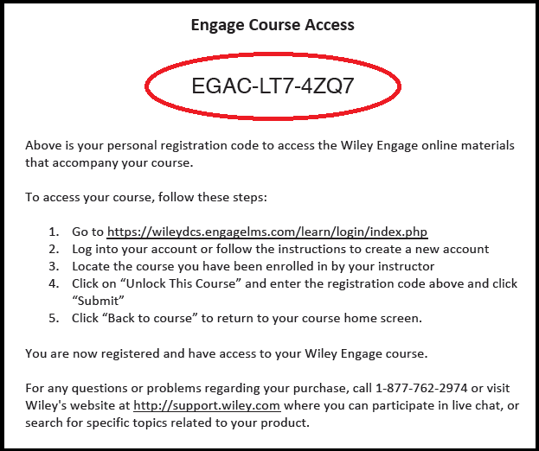  Or Wiley Online Shopping Cart Confirmation Email (sample)  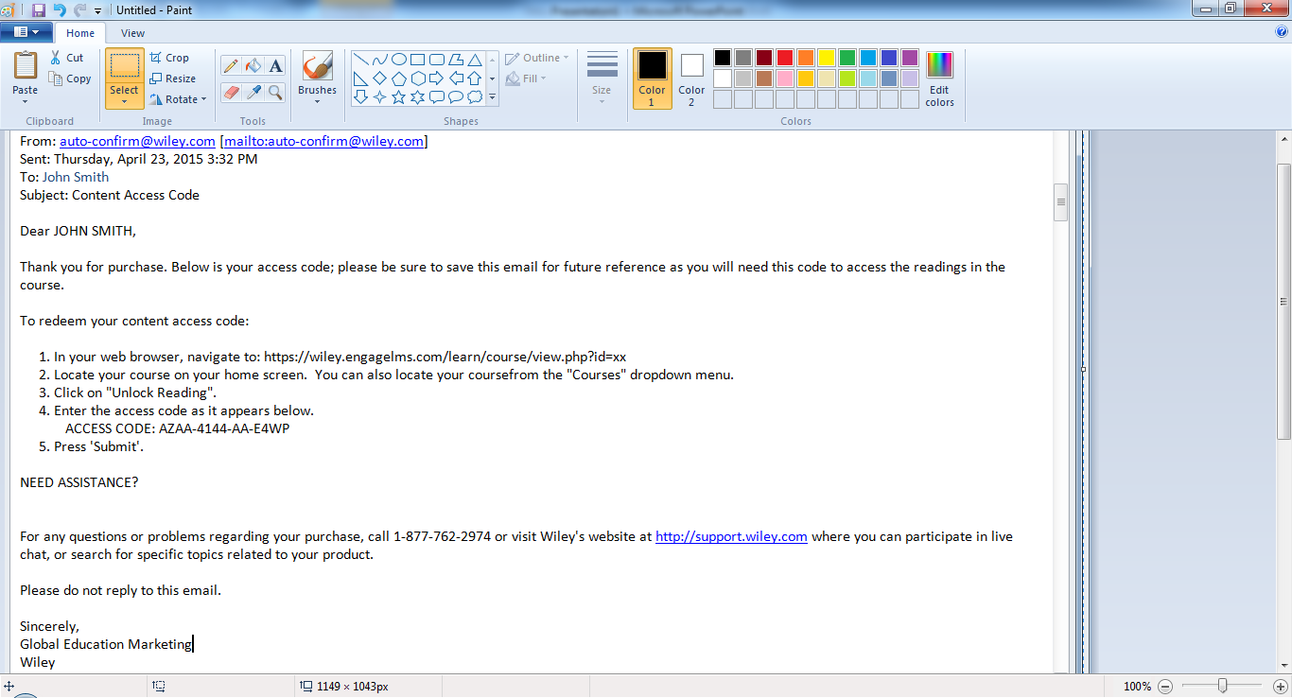  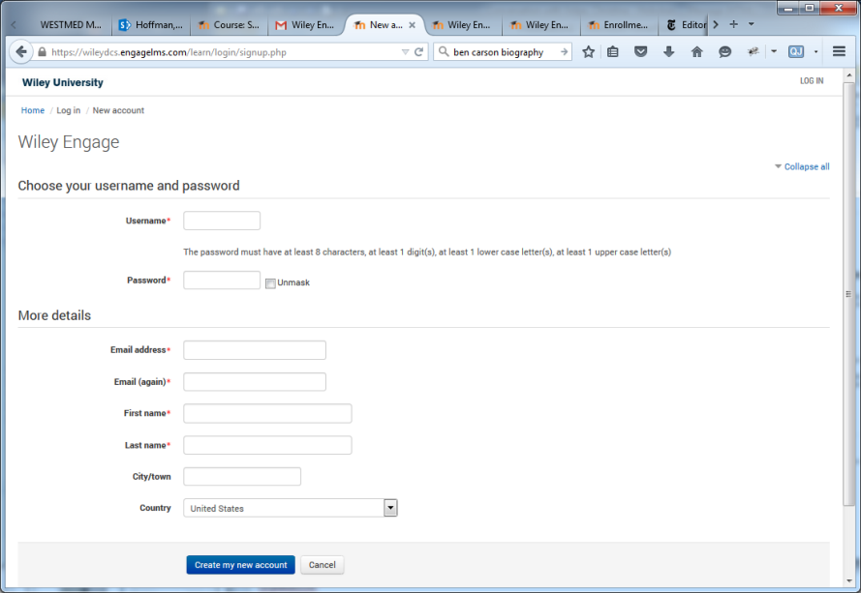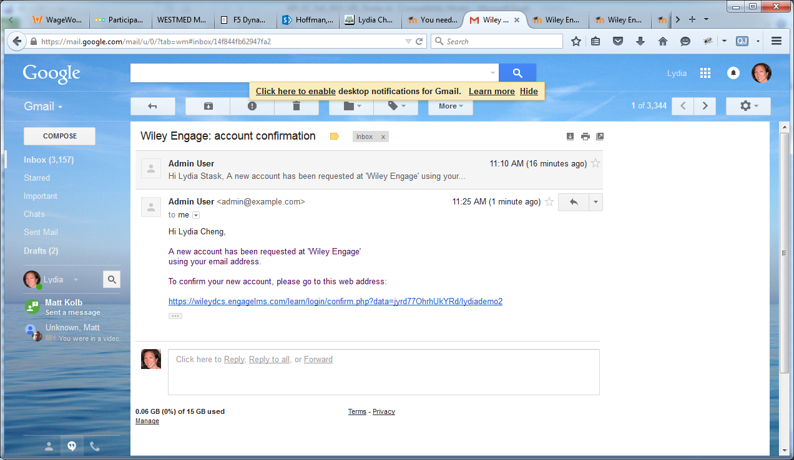  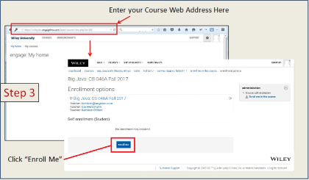  Course Section Web Links  Section Web Link Instructor  https://wileydcs.engagelms.com/learn/course/view.php?id=734 O’Brien  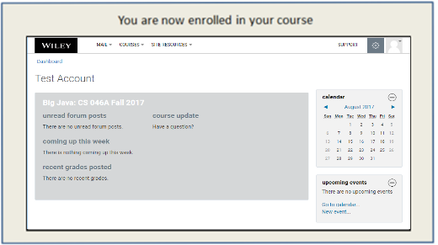  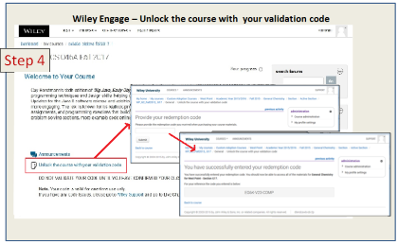  Wiley Engage: Accessing your eText Readings  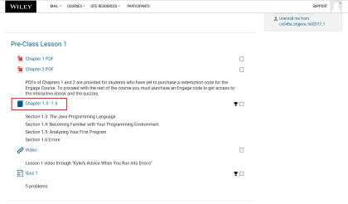  Wiley Engage: Accessing the Bookshelf for the First Time  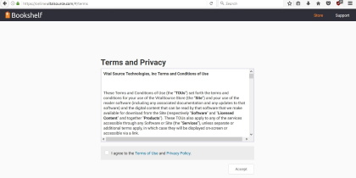  Wiley Engage: Setting up a Bookshelf Account  Viewing your integrated e-text within your Wiley course:  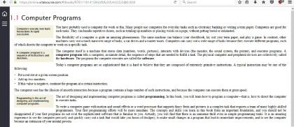  Wiley Engage: Support Information  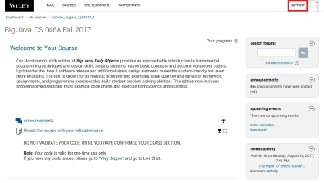 | Step 1:  PURCHASE YOUR REGISTRATION CODE from the Bookstore  Locate the printed registration card with your registration code. Do not throw this out.  OR  PURCHASE THE CODE ONLINE USING THIS URL:  http://customer.wiley.com/CGI-BIN/lansaweb?procfun+shopcart+shcfn01+funcparms+parmisbn%28a0100%29:1119444314+parmqty%28p0050%29:1  NOTE: Do not purchase the e-Book by itself because it is included in the course. If you purchase the book or e-Book using any other method you will not be able to access the online course.  If you purchase your code online, you will receive a confirmation email that contains your course registration code, which you'll be asked to enter after you log into your course for the first time.  Step 2: Set Up Your Wiley Engage Account  Go to: https://wileydcs.engagelms.com/learn/login/index.php  - Click on the button “Create new Account” under the “Is this your first time here?”  - Fill out the New Account form with your details.  - An email confirmation will be immediately sent to your email address.  - Read your email, and click on the web link it contains.  - Your account will be confirmed and you will be logged in.  Step 3: Enroll in your Course  - While logged in, use the course Section Web Link provided by your instructor below. Either click on the Web Address or copy and paste the link into the address bar in your browser.  - You will now see your course listed. To enroll, click on the button “Enroll me” and you will now access your course.  - From now on you will only need to enter your personal username and password (in the form on this page) to log in and access any course you have enrolled in.  Course Section Web Links  Please use the link on the left when accessing your course for the first time.  Step 4: VALIDATE YOUR CODE  Next, you’ll need to validate the code so go back to Step 1 and locate your validation code.  - Click on the link on the course homepage that says “Unlock course with your validation code.”  - On the next screen, enter the code printed on your registration card or in the email confirmation from Step 1 into the field, and click Submit.  - Once you’ve successfully entered your code, you’ll see a validation screen with your username displayed.  - Click the link that says “Back to course” to return to the course home page.  - Click on the “Welcome to Taxation for Decision Makers” to get tips.  TROUBLESHOOTING  Q: I get an error message that says my code has already been used.  A: Access Wiley’s LIVE CHAT support at https://hub.wiley.com/community/support/wileyplus. Be ready to provide your name, email address, school, and course name.  Congratulations! You are now ready to begin using your course on the Wiley Engage platform.  Step 5: Accessing your eText  After you log into your Wiley Engage course, click on the Readings for the first time and you will be sent to the Bookshelf page.  Click “Continue” on the Terms of Use screen.  If you get a blank screen or the title is not loading properly, go the “Welcome to General Chemistry for West Point” and scroll down to see the browser settings.  TROUBLESHOOTING  Q: I can log into my course, but I don’t see the embedded ebook.”  A: Try refreshing the page, or logging in with a different browser; we recommend using Chrome, Firefox, or Internet Explorer version 9 or above. If that doesn’t work, email CustomSupport@wiley.com.  Your eText Bookshelf Account  The next screen will prompt you to set up a VitalSource Bookshelf Account to access the eText offline or on your mobile device or you can click “Continue Without Registering”. You will then view your eText.  If you want to access this eText without logging into the Wiley Engage course, you will need to create Bookshelf account by clicking on the “Finish configuring your account” link.  For more information about how to download Bookshelf or use your Bookshelf to take search, notes, highlight and more, go to https://support.vitalsource.com/hc/en-us  Wiley Engage Support  For questions about navigating throughout your course, click on the Support link on the upper right side of the course page.  The Support page contains lots of useful information about how to navigate and use the Engage platform.  If you have any questions or comments, please email CustomSupport@wiley.com/.

